: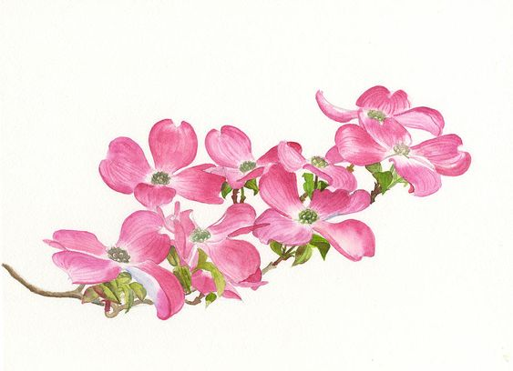 November Bloomin’ News
As always, our November meeting was a busy one…but probably the most significant action was electing and swearing in a new board for 2022. For those not at the meeting, welcome our new board:
Debbie Bybee-Crumpley – President
Carol Game – Vice President
Maureen Julian – Secretary
Norma Ray – Treasure

We are rapidly running down to the end of 2021; I know a lot of people will be glad to see this year in the review mirror – but we still have several tasks and projects to wrap up.
2021 Community Contributions:
The board presented the below as a proposed recommendation. If have another organization you would like us to consider please forward to me by November 19th.
- Pollock Pines / Camino Community Center - $500
- Pollock Pines Community Church - $500
- Friends of the Library - $500
- Pollock Pines Boys & Girls Club - $365
- Blooms on Wheels - $75
- Interact Club - $60
Christmas Boughs:
For the new member we make about 45 Christmas boughs every year and hang them around Pollock Pines and Camino. We will be making them on November 30th at 11:00 am at the PP/C Community Center. We still need 4-5 people so if you like to join in the fun of making the boughs, please contact me directly.
Holiday Craft Faire:
November 19th from 5:00pm to 9:00 pm and November 20th from 9:00 am to 3:00 pm. We have sold out with 22 vendors.
We still need people to help working the event – if you can assist, please contact Norma Ray to work out times, etc.
Christmas Bake Sale:
We will have 2 tables at the Holiday Craft Faire for our annual bake sale. We need people to help set-up, work the booth selling and baked goods and most importantly to bake the goods. If you want to be involved in any of the tasks, please contact Carol Game to work out the logistics. If you bake goods and need tags to label the bags let me – I have created Dogwood Garden Club labels that I can send you.
Breakfast with Santa:
December 4th at the PP/C Community Center. We need 4 people to assist Maureen in helping the kids make Christmas ornaments. If you want to help a bunch of kids have a great time, please contact Maureen Julian directly.
Dogwood Garden Club Christmas Party:
December 1st from 11:00am to 3:00 pm at the Sequoia Mansion on Bee Street in Placerville. If you have not signed up or have not paid, I have attached a form for you to complete and send in with your check. I apologize for the confusion over “Filet” it is a Filet Mignon.
2022 Renewals:
I know, it seems like we just did this…but with luck we will be able to start 2022 as we always have in the past, and to that end it is the standard time for renewals. The fee goes back to the standard annual fee of $30 – they are considered past due if not received by Feb 15th 2022. I have attached the 2022 renewal form for you to include with your checks.

