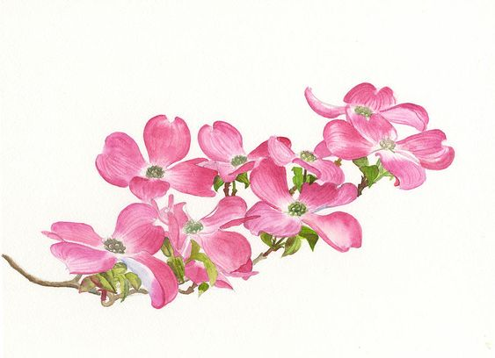 DOGW OOD GARDEN CLUB
Feb. 7, 2024 Minutes
Meeting was called to order by President, Debbie Bybee-Crumpley at 11:004. She thanked Sandra Morgan for helping with organizing the meeting at the Church.
Welcome - Debbie welcomed everyone. There were 27 people at the meeting.
Approval of the November 2023 minutes – motion for approval was made by Marilynn Johnson and seconded by Jeri Hartman

2023 Financial Review copies of the final budget were on the tables for review prior to the meeting. Barbara O’Sullivan presented the final Treasurer report for 2023. Balance of $2793.53 + $500.00 (deposit fr Placerville Shakespeare Club) making our beginning balance for 2024 $3293.53

Renewals – Emails have been sent to those still needing to renew for 2024, Renewals are due February 15, 2024. DGC POB 1074, Pollock Pines, CA 95726
Current Business – None
Other Business – None
Elections for 2024 DGC Board - Debbie Bybee-Crumpley swore in the following members to serve on the Board for 2024:
President Norma Ray
Vice President Allison Knight
Secretary Theresa Magnuson
Treasuerer Lexa Mack has been issued a letter that she will sign accepting the position
Batton was passed to the new board.

2024 Business -
Norma thanked the previous board for all their hard work these past couple of years.

2024 Budget -
Board plans to meet after March meeting. Budget will then be distributed via the Blooming, for member for at April Meeting.

Coordinators -
Most of the positions have been filled.
Membership Coordinator – currently Theresa Magnuson has agreed to temporarily fill along with her Secretary duties.
Birthday Lunches – Laura Llamas and Karen Fryxell
Sunshine _ Jeri Hartman
Bake Sale Coordinator – Lauran Goddard will do craft fair ONLY. Need Coordinator(s) for Wagon train and July 4th
Potential May Tea Part Fundraiser Coordinator – Allison Knight
Sly Park Planting Boxes Coordinator – Patty Noble
Judy Morgan Park Clean Up Coordinator – Theresa Magnuson
Sunshine Coordinator – Jeri Hartman
Holiday Craft Fair Fundraiser Coordinators – Norma Ray and Jan Slominski
Boys and Girls Club Christmas Store – Kay Campbell
Blooms on Wheels – Pat Schoggins
Raffles – Debbie Bybee-Crumpley
2025 Board Member Recruitment Committee – Debbie Bybee-Crumpley, Barbara O’Sullivan, Maureen Julian and Becky McIntyre

Sunshine - Jeri Hartman reviewed Sunshine –
Louise Bunny passed away
Birthday Lunch
February 14 2024, 1130, Public House, 301 Main St, Placerville,
March 13 2024, 1130, Sportsman Hall, 5620 Pony Express, Camino
April 10 2024, 1130, Pizza Fatory, 1242 Broadway, Placerville (behind Taco Bell)
No reservations required, plenty of parking, separate checks and booze!

2024 Calendar Tentative
March – Marlene Simon from UC Davis (The Plant Lady) will give a presentation. Location is Sierra Springs Club House: 4240 Sierra Springs Drive, Pollock Pines

April – Jollity Goat Farm , 5314 Mari Gold Mine, Garden Valley Ca 95633
May or June- Cooking Class at Allison Knights house or Lily Farm
July – Green Acres, Folsom
August – Luau
September – Apple Hill
October – Winery
November – Pot Luc
December – Christmas Party

These are all tentative with the exception of March Meeting.
Any suggestions for locations or topics, please provide to the DGC Board.

May Fundraiser tentative Tea Party open to the public. Lots of discussion on possible locations and ideas. Gold Ridge Lodge? Placerville Shakespeare Club?
Allison Knight is heading this up, call her with any suggestions. She will need volunteers to assist.

Raffles -
Debbie Volunteered to be the Coordinator for our raffles. Looking at having 3 a year. 1st one is in March. If you have items for the raffle contact Debbie for pick up prior to meetings or bring the item day of raffled.
2nd and 3rd raffles TBD

Wagon Train
Valerie asked for volunteers for Wagon Train this year
75th year, June 07

Logging Days
Valerie is looking for Vendors/Volunteers July 19-20 do not have alit of all the activities over the 2 days, but there will be a dinner/dance.

Other Business -
Pat Schoggings wanted to thank all of the members that help clean up the Library. There is local gentlemen, Mark Weiner (sp?), who has agreed to leaf blow the area on a regular basis. If volunteers are needed she will let us know. She aslo mentioned the 2024 News Letter Friend of the Library is available on the tables.

Leslie Sinclair – Marshall Medical Is looking for volunteer greeters. Contact Leslie if interested
Meeting adjourned at 1140 and broke for Potluck

